**NATIONAL TECHNOLOGY DAY**

**TYPES OF ENGINEERS**

**MECHANICAL ENGINEER**

**ELECTRICAL ENGINEER**

**AEROSPACE ENGINEER**

**CHEMICAL ENGINEER**

**COMPUTER SCIENCE ENGINEER**

**AUTOMOBILE ENGINEER**

**ELECTRONIC ENGINEER**

**BIOMEDICAL ENGINEER**

**ENVIROMENTAL ENGINEER**

**SORTWARE ENGINEER**

**CIVIL ENGINEER**

**MECHANICAL ENGINEER**



[This Photo](https://www.deviantart.com/nomadicstardust/art/Mechanical-Engineer-Logo-491264503) by Unknown Author is licensed under [CC BY-NC-ND](https://creativecommons.org/licenses/by-nc-nd/3.0/)

Mechanical engineering is the study physical machines that may involve force and movement .

**ELECTRICAL ENGINEER**

**Electrical engineering is an engineering discipline concerned with the study design and application of equipment devices and which use electricity electronic and electromagnetism .**

**AEROSPACE ENGINEER**

Aerospace engineering is the primary field of engineering concerned with the development of aircraft and spacecraft .



**CHEMICAL ENGINEER**

**Chemical engineering is an engineering field which deals with the design of chemical plants as well methods of improving production**

**COMPUTER SCIENCE**

Computer science engineering is the most popular branch of engineering and rank the highest among all the different types of engineering cources in india



[This Photo](https://syntaxacer.deviantart.com/art/Computer-Science-206977397) by Unknown Author is licensed under [CC BY-NC-ND](https://creativecommons.org/licenses/by-nc-nd/3.0/)

**AUTOMOBILE ENGINEER**

Automotive engineering is a branch of vehicles engineering that focuses on application design and manufacture of various types of automobile .

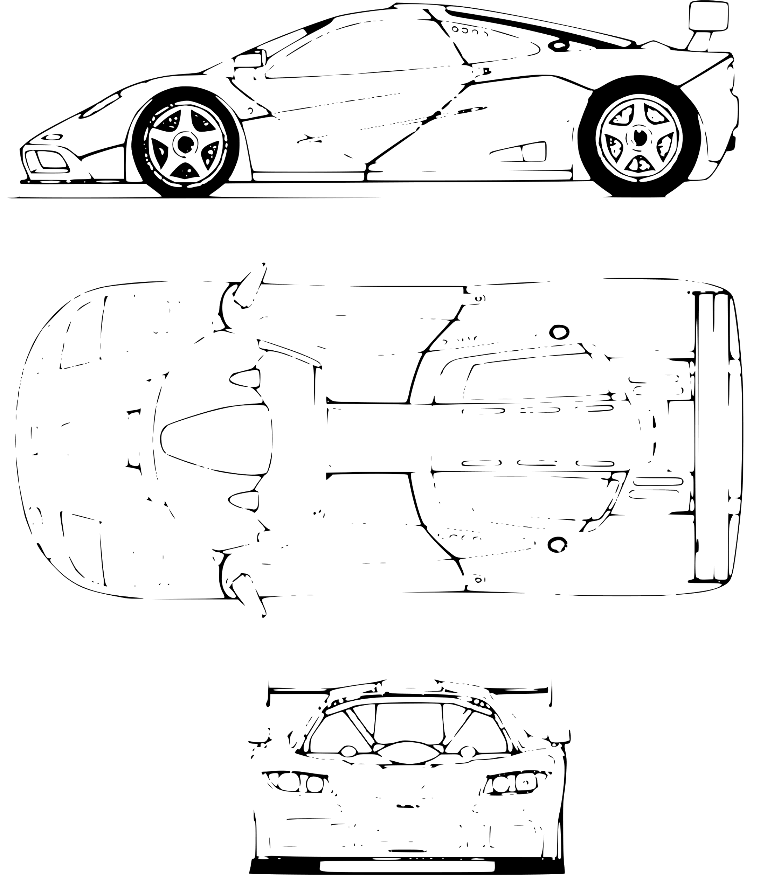

**BIOMEDICAL**

**Biomedical engineering focuses on the advances that improve human health and health care at all levels and is the application of the principals and problem-solving technique of engineering to biology and medicine .**



[This Photo](https://bmcbiomedeng.biomedcentral.com/articles/10.1186/s42490-019-0011-2) by Unknown Author is licensed under [CC BY](https://creativecommons.org/licenses/by/3.0/)

**CIVIL ENGINEER**

**Civil engineering a professional engineering discipline that dels with the design construction and maintenance of the physical and naturally built environment , including public works such as roads bridges , canals , dams , airports , sewage systems , pipelines , structuals components of buildings , and railway .**



[This Photo](https://www.onecommunityglobal.org/seeking-engineers/) by Unknown Author is licensed under [CC BY](https://creativecommons.org/licenses/by/3.0/)